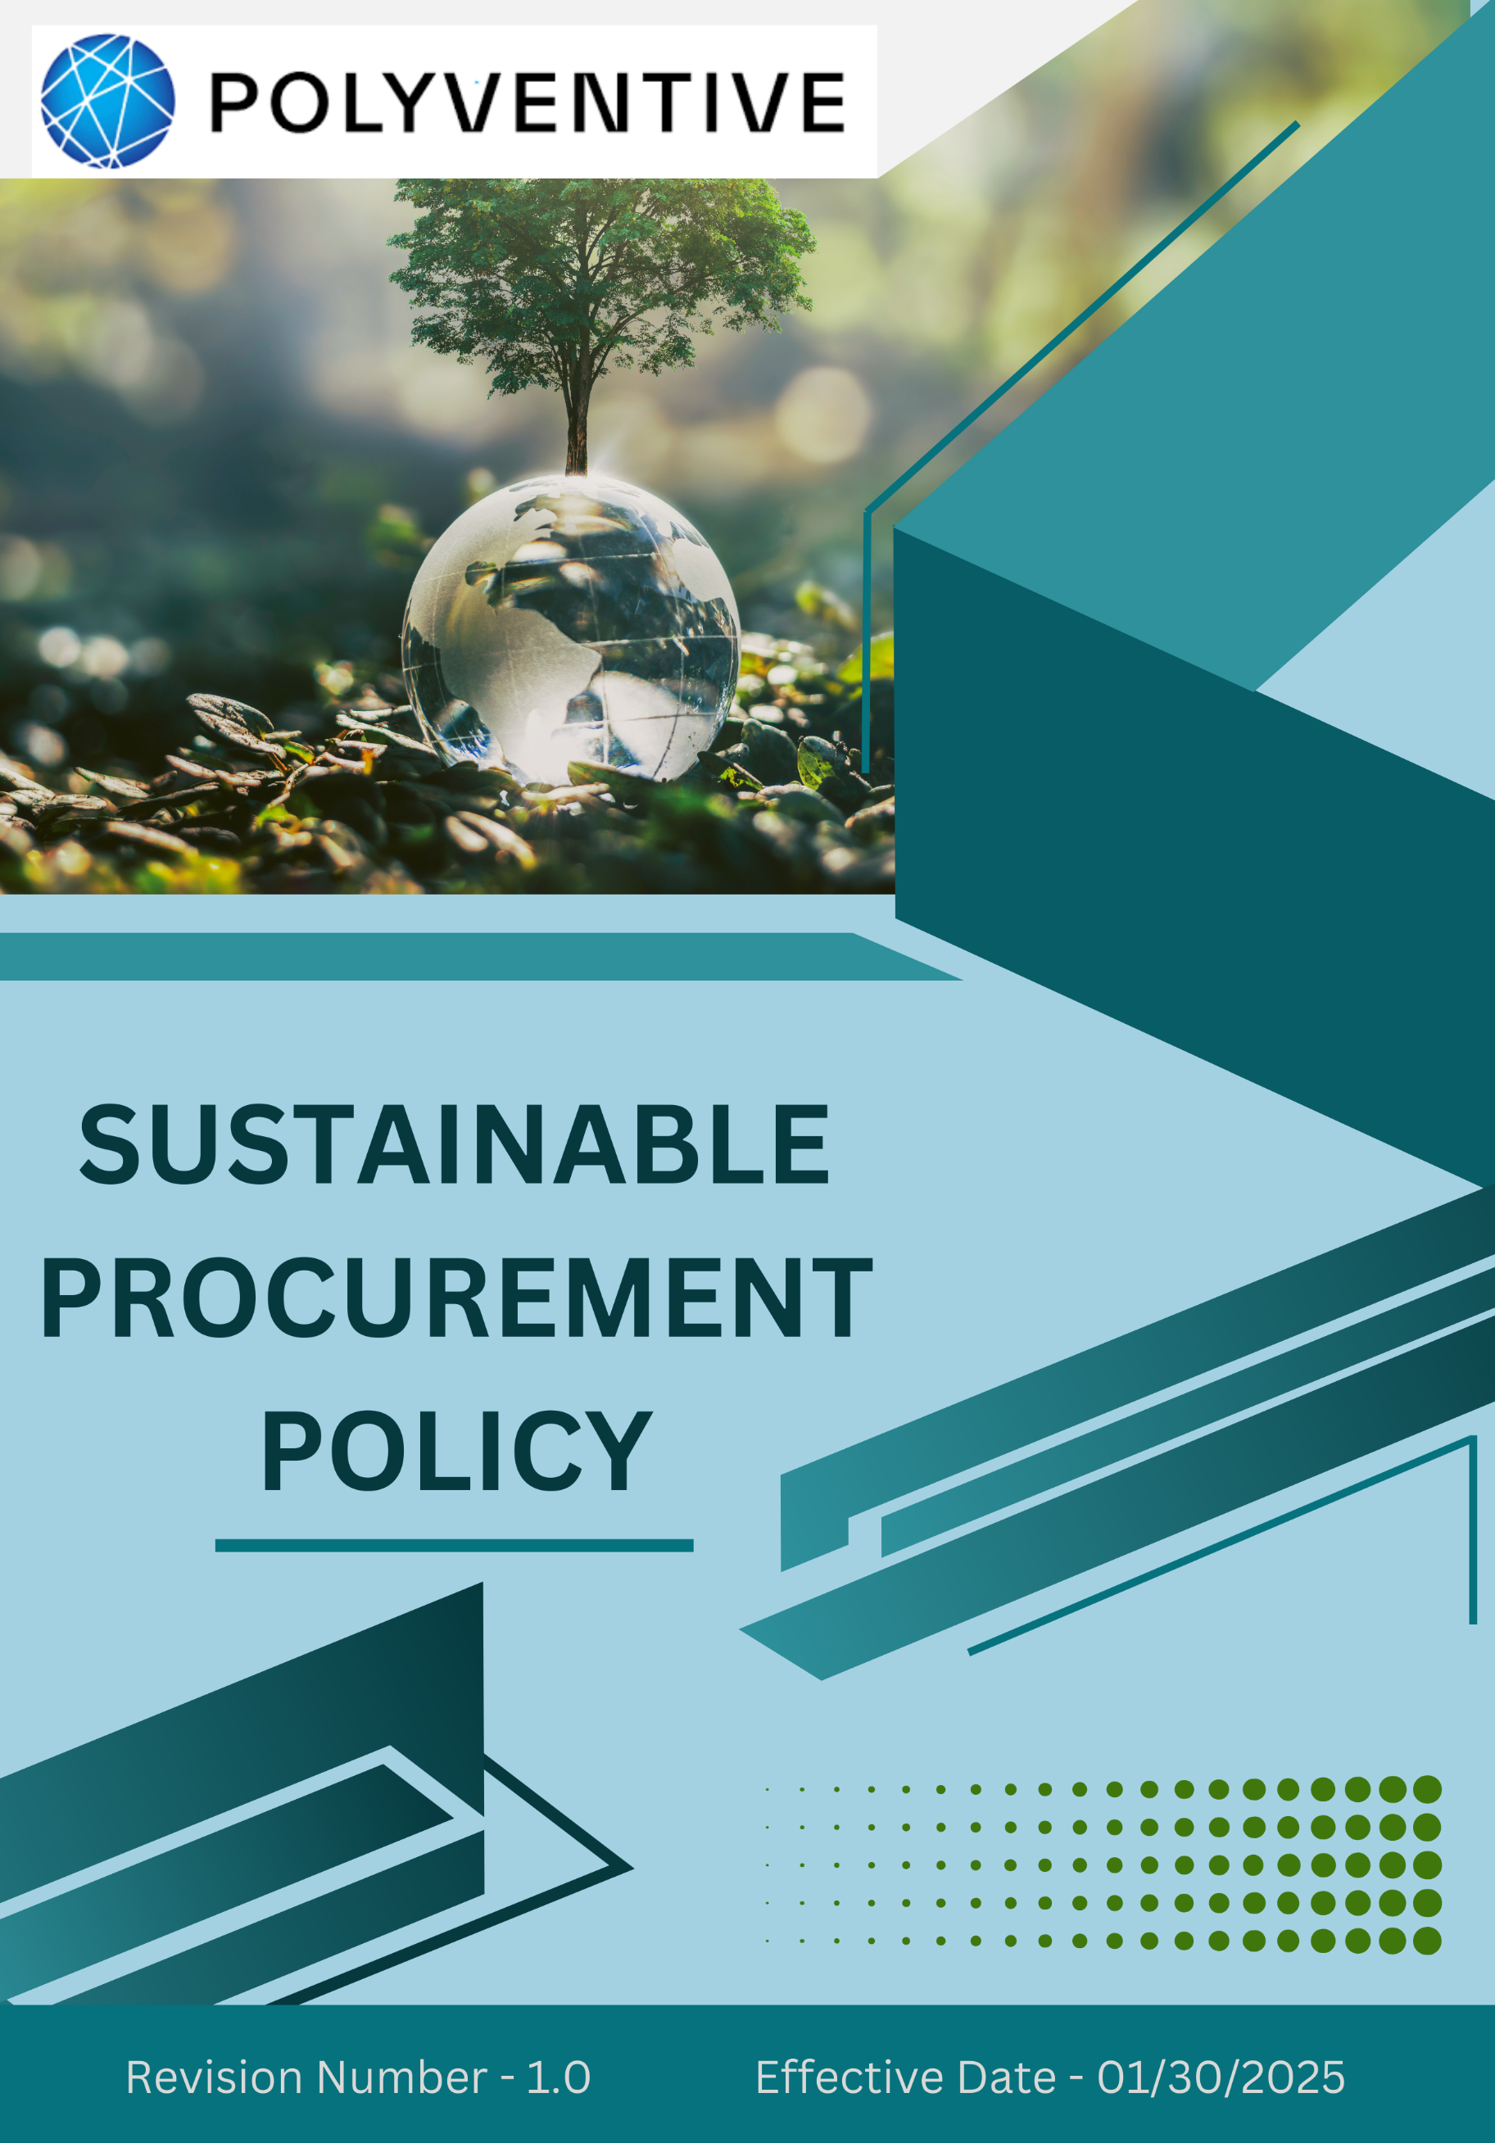

Index

❖ Introduction: 3
❖ Scope: 3
❖ Sustainable Procurement Commitment: 4
❖ Quantitative Targets: 6
❖ General sustainable procurement targets: 6
❖ Action Framework: 7
❖ Roles and Responsibilities: 8
❖ Monitoring and Reporting: 9
❖ Communication and Transparency: 9
❖ Continuous Improvement: 10
❖ SDGs (Sustainable Development Goals) Covered in the Sustainable Procurement Policy 10
❖ Review: 11
❖ Employee Acknowledgment: Sustainability Procurement Policy 12

Introduction:
At POLYVENTIVE LLC (GROUP), we are committed to ensuring fair and equitable wages for all employees. We believe that every worker deserves compensation that meets their essential needs and supports a dignified standard of living. This Living Wage Policy reflects our dedication to human dignity, responsible business conduct, and alignment with international labor and human rights standards. Through this initiative, Polyventive seeks to enhance employee well-being and foster sustainable economic growth in the communities where we operate.

Scope:
This policy applies to all POLYVENTIVE LLC (GROUP) employees, workers, contractors, sub-contractors, suppliers, partners, and stakeholders across all operational Global locations. It covers our manufacturing sites, offices, and all associated business operations, and extends to interactions with clients, vendors, regulators, and the wider community.

Sr. No. | Address
1 | 140 Executive Dr SE, Calhoun, GA 30701
2 | 130 Executive Dr SE, Calhoun, GA 30701
3 | 1601 US-41, Calhoun, GA 30701
4 | Burlington Rd NE, Rome, GA 30161
5 | 1202 Dozier St., Dalton, GA 30721
6 | 1001 Boul Industrial St-Eustache, QC, J7R 6C3 Canada
7 | 6060 Rickenbacker Rd., Commerce, CA 90040

Sustainable Procurement Commitment:
Polyventive is committed to ensuring that every procurement decision we make generates positive outcomes for the environment, society, and the global communities in which we operate. Our commitment is built on four interconnected pillars:
- Environmental Responsibility in Procurement
Polyventive is dedicated to reducing the environmental impact of its procurement activities by sourcing raw materials, packaging, and services from environmentally responsible partners. We prioritize engagement with suppliers that:
- Collaborate with suppliers that are certified to Net Zero standards or hold ISO 14001/ISO 50001 Environmental Management certifications
- Suppliers must demonstrate full compliance with all applicable local and international environmental regulations, laws, and guidelines.
- Integrate renewable, recycled, or bio-based materials into their products and solutions.
- Implement energy-efficient processes and technologies to minimize greenhouse gas emissions.
- Adopt effective waste minimization, safe handling of chemicals, and responsible waste management systems.
- Demonstrate sustainable water management practices, including conservation and pollution prevention.
- Provide training to the procurement team on environmental issues associated with procurement activities
- Labor Practices and Human Rights
Polyventive maintains a zero-tolerance policy toward any violations of human rights within its supply chain. We expect our suppliers and contractors to:
- Collaborate with suppliers that are certified to hold ISO 4500/SA8000 Social issues certifications
- Suppliers must demonstrate full compliance with all applicable local and international social regulations, laws, and guidelines.

- Fully comply with applicable national and international labor laws, including fair wages, working hours, and employee benefits.
- Ensure safe and healthy working conditions, minimizing risks associated with chemical handling and industrial operations.
- Strictly prohibit child labor, forced labor, and all forms of modern slavery or human trafficking.
- Foster diversity, equity, and inclusion by promoting equal opportunities regardless of gender, race, religion, or background.
- Provide training to the procurement team on social issues associated with procurement activities
- Ethical Sourcing and Fair Trade
Polyventive promotes ethical sourcing practices and supports the adoption of fair-trade principles wherever applicable. We seek to work with suppliers who:
- Provide fair and transparent compensation while operating free of exploitative practices.
- Support smaller producers, cooperatives, and local suppliers aligned with fair trade or socially responsible standards.
- Enhance social accountability and fairness across every tier of the supply chain.
- Supplier Engagement and Development
At Polyventive, we believe in building strong, collaborative partnerships with our suppliers. We support their sustainability journey through:
- Technical guidance, training, and capacity-building initiatives.
- Transparent communication and regular feedback mechanisms.
- Joint efforts to advance ESG performance, meet evolving industry standards, and respond to stakeholder expectations.
Supplier performance is continuously monitored and reviewed to ensure alignment with Polyventive’s sustainability objectives and to drive continuous improvement.

General sustainable procurement targets:
- Annual Supplier Assessments & Audits: By Year 2030, 100% of our suppliers will undergo an annual sustainability assessment and audit to verify performance across environmental, social, and governance (ESG) criteria.
- Certified-Only Sourcing: By Year 2030, 100% of our procured goods and services will be sourced exclusively from suppliers holding recognized sustainability certifications such as ISO 14001, Fair Trade, or equivalent standards relevant to the chemical industry.
- Supplier Capacity Building & Training: By Year 2030, 100% of our suppliers will receive annual sustainability training and resource support to help them meet Polyventive’s environmental and social standards effectively.
- Local & Community Sourcing: By Year 2030, at least 25% of our goods and services will be sourced from local or community-based suppliers to support regional economies and reduce supply chain carbon emissions through minimized transportation.

Quantitative Targets:
- Polyventive sets 2022 as the baseline year for tracking progress on its Sustainable Procurement initiatives.

- Environmental Sustainability in Procurement
- Ensure that 75% of Polyventive’s suppliers meet defined environmental sustainability criteria by Year 2030.
- Achieve a 20% reduction in supply chain carbon emissions through the procurement of energy-efficient materials, responsible logistics, and eco-conscious services by Year 2030.
- Increase the procurement of renewable, bio-based, or recycled raw materials by 20% by Year 2030.

- Labor Practices and Human Rights in Procurement
- Conduct audits of 100% of high-risk suppliers to ensure compliance with labor practices, human rights, and workplace safety standards by Year 2030.
- Ensure that 100% of Polyventive’s suppliers comply with company standards on fair wages, safe working conditions, and labor rights by Year 2030.

- Fair Trade and Ethical Sourcing
- Ensure that at least 50% of goods and raw materials sourced from developing regions meet fair trade or equivalent ethical sourcing standards by Year 2030.

Action Framework:
To effectively implement its Sustainable Procurement Policy, Polyventive adopts a structured action framework focused on transparency, accountability, and continuous improvement:

- Supplier Assessment: Polyventive evaluates its suppliers’ environmental performance, labor practices, and compliance with human rights standards. Assessments may include site visits, documentation reviews, and verification through third-party certifications. Suppliers are expected to meet stringent ESG standards, and regular evaluations ensure responsible and resilient supplier relationships.

- Supplier Code of Conduct: Polyventive maintains a Supplier Code of Conduct that sets clear expectations regarding environmental responsibility, ethical labor practices, workplace safety, and human rights. All suppliers must formally commit to and comply with this Code, which is periodically updated to align with international benchmarks and regulatory standards. Compliance is a mandatory condition for continued supplier engagement.

- Capacity Building and Collaboration: Polyventive supports its suppliers by offering training, workshops, and technical guidance designed to strengthen sustainability performance. Knowledge-sharing on safe chemical handling, energy efficiency, and carbon reduction strategies is encouraged. Collaborative engagement ensures stronger human rights practices, fair labor conditions, and mutual growth across the supply chain.

- Regular Audits and Corrective Action: Routine audits are conducted to monitor supplier compliance, particularly in high-risk regions or sensitive product categories. Where non-compliance is identified, suppliers must implement corrective action plans within defined timelines. Persistent violations may result in suspension or termination of contracts. These audits reinforce accountability, transparency, and adherence to Polyventive’s ESG standards.

Roles and Responsibilities:
- Chief Procurment Officer (CPO): The CPO holds primary accountability for the execution of Polyventive’s Sustainable Procurement Policy. This role ensures that all procurement strategies align with the company’s sustainability vision and ethical sourcing commitments. The CPO also guides the integration of ESG considerations into procurement systems, reviews progress against defined sustainability targets, and undertakes an annual review of the policy to ensure its continued relevance and effectiveness.

- Sustainability and Compliance Team: This team works closely with procurement to assess supplier performance, monitor compliance with sustainability standards, and facilitate regular audits. The team also maintains and updates Polyventive’s Supplier Code of Conduct, ensuring alignment with evolving ESG expectations, industry best practices, and global regulatory requirements.

- Procurement Managers: Procurement Managers are responsible for embedding sustainability criteria into day-to-day procurement decisions. They engage directly with suppliers to ensure compliance with Polyventive’s environmental, labor, and human rights expectations, while also supporting suppliers in improving their sustainability practices through guidance, training, and collaboration.

- Suppliers: Suppliers are expected to uphold Polyventive’s standards on environmental stewardship, ethical labor practices, and responsible sourcing. They must provide transparent reporting on sustainability performance, participate in audits and assessments, and engage in capacity-building initiatives to ensure continuous improvement in ESG performance.

Monitoring and Reporting:
- Supplier Performance Reports: We prepare routine performance reports that assess suppliers’ compliance with environmental, labor, and ethical standards. These reports guide our procurement decisions and help us drive continuous improvement across our supply chain, reflecting our commitment to transparency and accountability.
- Audit Reports: Our Sustainability and Compliance Team facilitates supplier audits, and we thoroughly review all findings. Whenever non-compliance is identified, we immediately implement corrective action plans. This demonstrates our ongoing dedication to ethical procurement and supplier accountability.

Communication and Transparency:
- Our Sustainable Procurement Policy is publicly available on our website, showcasing our commitment to responsible sourcing and sustainability. This aligns with our ethos of “making responsible choices that safeguard people, products, and the planet.”
- We actively communicate this policy to all suppliers and business partners, making sure they clearly understand our sustainability expectations. This encourages constructive dialogue and strengthens collaboration around shared goals.
- To embed sustainable procurement principles across our organization, we provide dedicated training for all employees involved in procurement. This empowers our teams to make informed decisions, engage effectively with suppliers, and reinforce a culture of ethical stewardship that reflects our core values of safety, honesty, accountability, and environmental awareness.

Continuous Improvement:
Polyventive is committed to continuously improving its sustainable procurement practices to ensure ethical, responsible, and environmentally conscious sourcing across its global supply chain. As sustainability challenges evolve, we regularly update our policies, engage with suppliers, and embrace innovative solutions to reduce environmental impact, strengthen labor and human rights protections, and promote ethical trade. By fostering collaboration, leveraging recognized sustainability standards, and embedding innovation into our processes, Polyventive strives to remain at the forefront of responsible procurement and sustainable growth.

SDGs (Sustainable Development Goals) Covered in the Sustainable Procurement Policy





Review:
Polyventive’s Sustainable Procurement Policy will be reviewed annually by the Chief Procurement Officer (CPO) to assess progress against the company’s quantitative targets and evaluate the policy’s adaptability to emerging environmental, social, and governance challenges. Based on this review, necessary updates will be incorporated to enhance procurement effectiveness and responsiveness. Any changes to the policy will be promptly communicated to all employees and suppliers to ensure continued alignment and shared accountability.

Approved By:

Designation:

Last Review Date: 04/01/2025

Next Review Date: 04/01/2026

Employee Acknowledgment: Sustainability Procurement Policy
I hereby acknowledge that I have received, read, and understood the Polyventive Sustainable Procurement Policy. I affirm Polyventive’s commitment to responsible sourcing, environmental stewardship, and ethical labor practices across its global operations and supply chain.
I agree to uphold this policy in all procurement-related activities, ensuring that sustainability principles guide my decision-making. I pledge to collaborate with suppliers to enhance their sustainability performance while upholding Polyventive’s environmental, labor, and human rights standards. I further commit to promptly report any concerns or potential violations of this policy through the designated reporting channels.

Employee Name:

Employee Signature:

Date:

